**ANALYTICAL HIERARCHY PROCESS**

Based on the above results, we see that different measures add up to different aspects of a player’s abilities and hence different features have different ranges of importance e.g. batting average is an important factor for the game especially T20 as it reflects the run scoring abilities of a batsman in general. Similarly, strike rate plays an important role for limited over matches as it is important to score maximum runs in few overs. Hence, weighted measure of performance according to its relative importance over other different measures. We determined these weights for each player to calculate their batting and bowling ability using analytic hierarchy process (AHP). We have done same for the team based on their previous performances and calculated their weights using AHP.

AHP is an effective and very important tool for complex decision making. It aids in setting priorities depending on the features or attributes and gives the weight for each attribute according to its importance. It reduces complex decisions into a series of pairwise comparisons like comparing each feature with other features. It captures both subjective and objective aspects of a decision and hence it is considered one of the most important tool by data scientists for decision making. It generates a weight for each evaluation criterion according to the decision maker’s pairwise comparisons of the criteria. The higher the weight for a corresponding criterion, the more important is the corresponding criterion.

Finally, the AHP combines the criteria weights and the options scores, thus determining a global score for each option, and a consequent ranking.

The global score for a given option is a weighted sum of the scores it obtained with respect to all the criteria.

However, if the AHP is calculated using manual filling of the table and due to inconsistency in manual filling, the values that AHP will calculate might not be correct. However, this can be checked by calculating a parameter “Consistency Ratio”. If the value of “Consistency Ratio” is < 0.1, then the designed values are assumed to be correct otherwise there might be some discrepancy in filling the values.

**AHP References:**

**M. G. Jhanwar and V. Pudi (2016),** "Predicting the Outcome of ODI Cricket Matches: A Team Composition Based Approach," in *European Conference on Machine Learning and Principles and Practice of Knowledge Discovery in Databases.*

**Bandulasiri, A. (2008).** “Predicting the winner in one day international cricket” in *Journal of*

*Mathematical Sciences & Mathematics Education.*

**C. D. Prakash, C. Patvardhan and C. V. Lakshmi,** *"Data Analytics based Deep Mayo Predictor for IPL-*

*9," International Journal of Computer Applications, vol. 152, no. 6, pp. 6-10, October 2016.*

**AHP-Neural Network Based Player Price Estimation in IPL.** *“*International Journal of Hybrid Information Technology , Vol.7, No.3 (2014), pp.15-24 *”*

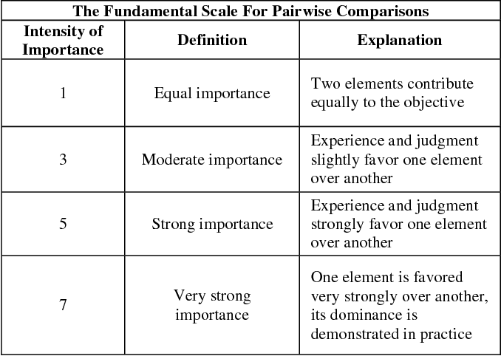

**BATTING AHP:**

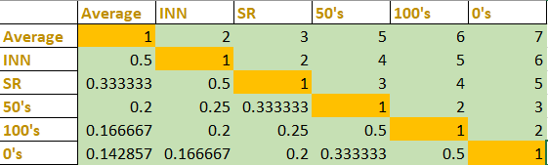

**Priority Order:**

**Batting Average > Innings > Strike Rate > 50’s > 100’s > 0’s**

**BOWLING AHP:**

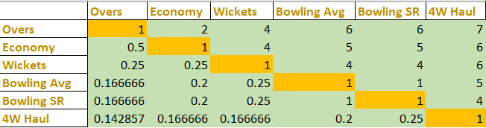

**Priority Order:**

**Overs > Economy > Wickets > Bowling Average > Bowling Strike Rate > 4W Haul**

**TEAM AHP:**

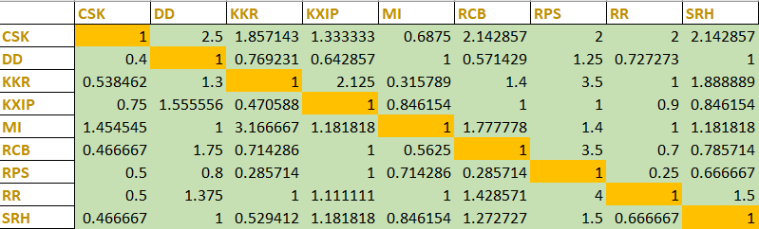

**Priority Order:**

**Calculated using match played for win/lose for each team against each team.**

**Eg.**

**CSK and MI has played in total 27 matches with each other and according to database MI has won 16 of them and rest 11 are won by CSK.**

**So in the MI row, it will be 16/11= 1.454545**

**For CSK, it will be reciprocal 1/1.454545= 0.6875**